**VIVEKANAND EDUCATION SOCIETY’S INSTITUTE OF TECHNOLOGY**

An Autonomous Institute Affiliated to University of Mumbai

Hashu Advani Memorial Complex, Collector Colony, Chembur East, Mumbai - 400074.

**DEPARTMENT OF ARTIFICIAL INTELLIGENCE AND DATA SCIENCE**



PROJECT REPORT ON

SecureGANs

IN PARTIAL FULFILLMENT OF THE FOURTH YEAR, BACHELOR OF ENGINEERING (B.E.) DEGREE IN ARTIFICIAL INTELLIGENCE & DATA SCIENCEAT VIVEKANAND EDUCATION SOCIETY’S INSTITUTE OF TECHNOLOGY, AN AUTONOMOUS INSTITUTE AFFILIATED TO UNIVERSITY OF MUMBAI. ACADEMIC YEAR 2023-2024

**SUBMITTED BY**

**ARUNIM CHAKRABORTY**

**SATYAM DUBEY**

**PRATHMESH PAWAR**

**YASH SARANG**

**PROJECT MENTOR**

**DR. ANJALI YEOLE**

(2023-24)

**VIVEKANAND EDUCATION SOCIETY’S INSTITUTE OF TECHNOLOGY**

An Autonomous Institute Affiliated to University of Mumbai

Hashu Advani Memorial Complex, Collector Colony, Chembur East, Mumbai - 400074.

**Department of Artificial Intelligence and Data Science**



# Certificate

This is to certify that ***Arunim Chakraborty, Satyam Dubey, Prathmesh Pawar, Yash Sarang*** of Fourth Year of **Artificial Intelligence and Data Science**  have satisfactorily completed the project on “***SecureGANs***” as a part of their coursework of PROJECT-I for Semester-VIII under the guidance of their mentor ***Dr. Anjali Yeole*** in the year 2023-2024 .

This project report entitled “***SecureGANs***” by ***Arunim Chakraborty, Satyam Dubey, Prathmesh Pawar, Yash Sarang*** is approved for the degree of B.E. in Artificial Intelligence and Data Science.

| Programme Outcomes | Grade |
| --- | --- |
| PO1,PO2,PO3,PO4,PO5,PO6,PO7,PO8,PO9,PO10,PO11,PO12,PSO1,PSO2 |  |

Date:

Project Guide:

Internal and External

------------------------------

# Project Report Approval

# for B. E (Artificial Intelligence and Data Science )

# 

This project report entitled “***SecureGANs***” by ***Arunim Chakraborty, Satyam Dubey, Prathmesh Pawar, Yash Sarang*** is approved for the degree of B.E. in Artificial Intelligence and Data Science.

Internal Examiner

---------------------------------------------

External Examiner

---------------------------------------------

Head of the Department

-----------------------------------------------

Principal

-----------------------------------------------

Date:

Place:

# 

# Declaration

We declare that this written submission represents our ideas in our own words and where others' ideas or words have been included, we have adequately cited and referenced the original sources. We also declare that we have adhered to all principles of academic honesty and integrity and have not misrepresented or fabricated or falsified any idea/data/fact/source in our submission. We understand that any violation of the above will be cause for disciplinary action by the Institute and can also evoke penal action from the sources which have thus not been properly cited or from whom proper permission has not been taken when needed.

| -----------------------------------------  Arunim Chakraborty - 07 | -----------------------------------------  Satyam Dubey - 13 |
| --- | --- |
| -----------------------------------------  Prathmesh Pawar - 42 | -----------------------------------------  Yash Sarang - 47 |

Date:

# ACKNOWLEDGEMENT

We are thankful to our college **Vivekanand Education Society’s Institute of Technology** for considering our project and extending help at all stages needed during our work of collecting information regarding the project.

It gives us immense pleasure to express our deep and sincere gratitude to Professor **Dr. Anjali Yeole** (Project Guide) for her kind help and valuable advice during the development of project synopsis and for her guidance and suggestions.

We are deeply indebted to Head of the Computer Department **Dr.(Mrs.) M. Vijayalakshmi** and our Principal **Dr. (Mrs.) J.M. Nair ,** for giving us this valuable opportunity to do this project.

We express our hearty thanks to them for their assistance without which it would have been difficult in finishing this project synopsis and project review successfully.

We convey our deep sense of gratitude to all teaching and non-teaching staff for their constant encouragement, support and selfless help throughout the project work. It is a great pleasure to acknowledge the help and suggestion, which we received from the Department of Artificial Intelligence and Data Science.

We wish to express our profound thanks to all those who helped us in gathering information about the project. Our families too have provided moral support and encouragement several times.

**Department of Artificial Intelligence and Data Science**

# COURSE OUTCOMES FOR B.E PROJECT

| **Course Outcome** | **Description of the Course Outcome** |
| --- | --- |
| CO1 | Identify problems based on societal /research needs. |
| CO2 | Apply Knowledge and skill to solve societal problems in a group |
| CO3 | Draw the proper inferences from available results through theoretical/ experimental/simulations |
| CO4 | Analyze the impact of solutions in societal and environmental context for sustainable development. |
| CO5 | Demonstrate capabilities of self-learning in a group, which leads to lifelong learning. |
| CO6 | Demonstrate project management principles during project work. |

# Table of Content

**Abstract** **1**

**List Of Figures** **3**

Chapter 1: Introduction 4

1.1 Motivation 4

1.2 Problem Definition 5

1.3 Relevance of the Project 6

1.4 Methodology used 7

Chapter 2: Literature Survey 10

2.1 Papers or books 10

2.2 Patent studies 12

Chapter 3: Requirements 16

3.1 Functional Requirements 16

3.2 Non-Functional Requirements 17

3.3 Constraints 19

3.4 Hardware & Software Requirements 20

3.5 System Block Diagram 23

Chapter 4: Proposed Design 24

4.1 System Design / Conceptual Design 24

4.2 Detailed Design 27

4.3 Plan of Work 30

4.4 Project Scheduling & Tracking using Gantt Chart 36

Chapter 5: Implementation 37

Chapter 6: Testing 39

Chapter 7: Result Analysis 40

7.1 Simulation Model 40

Fig 7.1 Simulation Model 40

7.2 Parameters / Graphs 40

7.3 Output Printouts 47

7.4 Observations & Analysis 49

Chapter 8: Conclusion 52

8.1 Limitations 52

8.2 Conclusion 53

8.3 Future Scope 54

References  56

Appendix57

# 

# Abstract

In the ever-evolving landscape of security and law enforcement, the integration of facial recognition technology has fundamentally transformed the identification and tracking of individuals involved in criminal activities. This revolutionary technology has enabled law enforcement agencies to swiftly and accurately identify suspects, track their movements, and prevent potential threats to public safety. However, the recent proliferation of face masks, spurred by the Covid-19 pandemic, has presented a formidable obstacle to the seamless operation of traditional facial recognition systems.

While recent advancements in deep learning-based image editing have showcased remarkable success in object removal tasks, they encounter significant hurdles when confronted with the complex and nuanced challenge of removing mask objects from facial images. The intricate nature of facial structures, coupled with the variability in mask types and placements, poses a formidable challenge to existing methodologies. As such, there exists an urgent need for innovative solutions that can effectively address this pressing challenge and ensure the continued efficacy of facial recognition technology in the face of evolving security threats.

In response to this imperative, this paper introduces a novel method aimed at removing mask objects from facial images through the application of image inpainting techniques. By leveraging advanced deep learning models such as Generative Adversarial Networks (GANs), our research endeavors to develop a robust and versatile system capable of accurately reconstructing obscured faces from security camera footage. The proposed approach represents a significant leap forward in the realm of facial recognition technology, offering a powerful tool for enhancing security efforts and safeguarding public safety.

Central to our methodology is the comprehensive evaluation of various inpainting techniques, conducted on extensive datasets such as CelebA and CelebA-HQ. Through rigorous comparative experiments, inspired by methodologies outlined in related works, our study seeks to refine and optimize facial recognition systems in masked scenarios. By systematically analyzing the performance of our proposed approach across a range of evaluation metrics, including peak signal-to-noise ratio (PSNR) and structural similarity (SSIM), we aim to demonstrate its effectiveness and efficiency in addressing this critical security challenge.

Furthermore, our research underscores the ethical and responsible deployment of surveillance technology, emphasizing the importance of balancing security imperatives with individual privacy rights. By advancing the state-of-the-art in image inpainting and drawing upon insights from related research, our work aims to pave the way for more effective and reliable facial recognition systems in masked scenarios. Through collaboration with law enforcement agencies and security experts, we envision a future where innovative technologies empower authorities to effectively combat crime and ensure the safety and security of communities worldwide.

# List Of Figures

| 1.1 Reference Imagery for Perpetrator Identification in Robbery Cases | 5 |
| --- | --- |
| 2.1 System Block Diagram for SecureGAN | 27 |
| 4.1 GANs Conceptual Design | 28 |
| 4.2 GANs Detailed Architecture | 31 |
| 4.3 Gantt chart of Project tracking - 1 | 38 |
| 4.4 Gantt chart of Project tracking - 2 | 38 |
| 5.1 UI - Login Page | 39 |
| 5.2 UI - Home Page | 39 |
| 5.3 UI - Upload Image | 40 |
| 5.4 UI - Unmasked Result | 40 |
| 7.1 Simulation Model | 42 |
| 7.2 Results - 1 | 50 |
| 7.3 Results - 2 | 50 |
| 7.4 Results - 3 | 50 |
| 7.5 Results - 4 | 51 |

## 

## Chapter 1: Introduction

### 1.1 Motivation

The motivation behind the SecureGANs project stems from the increasing concern over privacy and data protection in the digital age. With the proliferation of facial recognition technology and the widespread use of social media platforms, there is a growing awareness of the potential risks associated with the unrestricted sharing of personal images online.

The primary motivation for SecureGANs is to provide individuals with a means to protect their privacy while still being able to share visual content. By utilizing Generative Adversarial Networks (GANs), SecureGANs aims to generate synthetic images that preserve the overall visual characteristics of the original while concealing sensitive information, such as faces, through techniques like masking, blurring, or pixelating.

Key motivations for developing SecureGANs include:

1. Privacy Preservation: Many individuals are increasingly concerned about the potential misuse of their personal images, particularly in contexts where facial recognition technology is prevalent. SecureGANs offers a solution to this concern by enabling users to share images without revealing identifiable facial features.
2. Data Security: With the rise of cyber threats and data breaches, protecting sensitive information has become paramount. SecureGANs provides a tool to safeguard personal images, reducing the risk of unauthorized access or misuse.
3. Ethical Considerations: The use of facial recognition and image processing technologies raises ethical questions regarding consent, surveillance, and individual autonomy. SecureGANs promotes ethical image sharing practices by empowering users to control the visibility of their personal data.
4. Versatility and Customization: SecureGANs offers flexibility in how users can conceal faces within images, allowing for customization based on individual preferences and requirements. Whether it's applying masks, blurring, or pixelation, users have the ability to tailor the level of anonymity according to their needs.
5. Research and Development: The development of SecureGANs contributes to advancements in the field of computer vision, particularly in the domain of privacy-preserving image generation. By exploring innovative techniques for concealing faces in images, SecureGANs drives research in areas such as adversarial learning, image synthesis, and privacy-enhancing technologies.

Overall, SecureGANs aims to address the pressing need for privacy-enhancing tools in an era where personal data protection is paramount. By harnessing the capabilities of GANs, SecureGANs empowers individuals to share images with confidence, knowing that their privacy is safeguarded.

### 1.2 Problem Definition

**Fig 1.1 Reference Imagery for Perpetrator Identification in Robbery Cases**

The problem addressed by SecureGANs revolves around the need to balance the desire for sharing visual content with concerns about privacy and data protection. Specifically, SecureGANs aims to tackle the following challenges:

1. Privacy Risks in Image Sharing: Traditional methods of sharing images, such as through social media platforms or messaging apps, often involve the exposure of personal data, including identifiable facial features. This poses privacy risks, as individuals may inadvertently reveal sensitive information that could be exploited for malicious purposes, such as unauthorized surveillance or identity theft.
2. Lack of Control Over Image Visibility: Many existing image-sharing platforms offer limited options for controlling the visibility of personal data within images. Users may be unable to selectively conceal specific elements, such as faces, while still sharing the rest of the image content. This lack of control can deter individuals from sharing images altogether or lead to the inadvertent disclosure of sensitive information.
3. Invasive Use of Facial Recognition: The widespread deployment of facial recognition technology raises concerns about its potential misuse for tracking, profiling, or monitoring individuals without their consent. By allowing facial features to be easily recognizable in shared images, users may unknowingly contribute to the proliferation of surveillance systems and infringe on personal privacy rights.
4. Need for User-Friendly Privacy Solutions: While there are existing methods for anonymizing images, such as manual editing or image manipulation software, these approaches can be time-consuming, labor-intensive, and require technical expertise. Moreover, they may not always guarantee the preservation of image quality or the effective concealment of sensitive information.
5. Ethical Considerations in Image Processing: The development and deployment of image processing techniques must be guided by ethical principles, including respect for individual autonomy, consent, and privacy rights. SecureGANs seeks to address these ethical considerations by providing users with a privacy-enhancing tool that prioritizes user control and consent in image sharing.

In summary, the problem addressed by SecureGANs is the need for a user-friendly, effective, and ethically sound solution for concealing sensitive information, such as faces, in shared images. By leveraging the capabilities of GANs and innovative image processing techniques, SecureGANs aims to empower individuals to protect their privacy while still enjoying the benefits of sharing visual content online.

### 1.3 Relevance of the Project

The SecureGANs project is highly relevant in today's digital landscape due to its potential to address pressing concerns related to privacy, data protection, and ethical image sharing. Several factors underscore the relevance of this project:

1. Growing Concerns About Privacy: With the increasing prevalence of digital surveillance, data breaches, and privacy infringements, individuals are becoming more conscious of the need to protect their personal information, including images containing identifiable features. SecureGANs offers a proactive solution to mitigate privacy risks associated with image sharing.
2. Rising Adoption of Facial Recognition Technology: Facial recognition technology is being widely deployed in various sectors, including law enforcement, retail, and social media. However, its indiscriminate use raises concerns about surveillance, profiling, and privacy violations. SecureGANs provides a means to counteract the intrusive nature of facial recognition by allowing individuals to conceal their faces in shared images.
3. Ethical Considerations in Image Processing: The development and deployment of image processing technologies raise ethical questions regarding consent, autonomy, and the potential for harm. SecureGANs addresses these ethical considerations by prioritizing user control and consent in image sharing practices. By empowering individuals to selectively conceal sensitive information, SecureGANs promotes ethical image sharing practices aligned with privacy rights and individual autonomy.
4. Demand for Privacy-Enhancing Tools: As individuals become more aware of privacy risks associated with online activities, there is a growing demand for privacy-enhancing tools and technologies. SecureGANs fulfills this demand by offering a user-friendly solution for concealing faces in images, thereby enabling individuals to share visual content without compromising their privacy.
5. Technological Advancements in Image Synthesis: Recent advancements in deep learning, particularly in the field of Generative Adversarial Networks (GANs), have enabled significant progress in image synthesis and manipulation. SecureGANs leverages these technological advancements to develop sophisticated techniques for concealing faces in images while preserving visual fidelity and quality.
6. Legal and Regulatory Landscape: With the introduction of privacy regulations such as the General Data Protection Regulation (GDPR) and the California Consumer Privacy Act (CCPA), there is a heightened awareness of the importance of protecting personal data, including images. SecureGANs aligns with legal and regulatory requirements by providing individuals with tools to exercise greater control over their personal information and comply with privacy regulations.

In conclusion, the SecureGANs project is highly relevant in today's digital environment, where privacy concerns, ethical considerations, and technological advancements intersect. By offering a practical solution for concealing faces in images, SecureGANs addresses the evolving needs and challenges associated with privacy protection and ethical image sharing in the digital age.

### 

### 1.4 Methodology used

The methodology employed in the SecureGANs project involves a combination of deep learning techniques, specifically Generative Adversarial Networks (GANs), and image processing methods to generate synthetic images with concealed faces. The following outlines the key components of the methodology:

**Data Collection and Preprocessing**:

* + SecureGANs begins with the collection of a diverse dataset of images containing faces. These images serve as the basis for training the GAN model.
  + The dataset undergoes preprocessing to ensure uniformity in size, resolution, and format. Additionally, any identifying information or metadata associated with the images is removed to uphold user privacy.

**Training of Generative Adversarial Networks (GANs):**

* + GANs consist of two neural networks: a generator and a discriminator, trained simultaneously in a competitive manner.
  + The generator network learns to generate synthetic images that mimic the distribution of the training data, while the discriminator network learns to distinguish between real and synthetic images.
  + During training, the generator strives to produce realistic images that can "fool" the discriminator, while the discriminator aims to accurately distinguish between real and synthetic images.
  + The training process continues iteratively until both networks reach equilibrium, resulting in a generator capable of generating high-quality synthetic images.

**Privacy-Preserving Image Generation**:

* + Once the GAN model is trained, it can be used to generate synthetic images with concealed faces.
  + Various techniques such as masking, blurring, or pixelation are applied to hide facial features within the generated images.
  + The level of concealment can be adjusted based on user preferences or specific privacy requirements.

**Evaluation and Validation**:

* + The generated images undergo evaluation to assess their quality, realism, and effectiveness in concealing faces.
  + Metrics such as structural similarity index (SSIM), peak signal-to-noise ratio (PSNR), and perceptual similarity metrics may be employed to measure the similarity between the original and generated images.
  + Additionally, user feedback and subjective evaluation may be solicited to gauge the perceived effectiveness of the privacy-preserving techniques.

**Deployment and Integration**:

* + Once validated, the SecureGANs model can be deployed as a standalone application or integrated into existing platforms and services.
  + User-friendly interfaces are developed to facilitate seamless interaction with the SecureGANs system, allowing users to easily upload images, specify privacy preferences, and generate privacy-enhanced images.

**Continuous Improvement and Iteration**:

* + The SecureGANs methodology is subject to continuous refinement and iteration based on feedback, user experience, and advancements in deep learning and image processing techniques.
  + Regular updates and improvements are made to enhance the performance, usability, and privacy-preserving capabilities of the SecureGANs system.

In summary, the methodology used in the SecureGANs project leverages GANs and image processing techniques to generate synthetic images with concealed faces, thereby addressing privacy concerns associated with image sharing in a data-driven and user-centric manner.

## 

## **Chapter 2: Literature Survey**

### 2.1 Papers or books

* The paper by Ian Goodfellow et al. [1] signifies a significant leap in artificial intelligence through the introduction of Generative Adversarial Networks (GANs). GANs addressed the challenges faced by previous generative models in capturing intricate details of real-world data by employing an innovative adversarial training process. This paper delves into the fundamental concepts of GANs and their far-reaching impact across various applications in artificial intelligence. The adversarial nature of GANs, where a generator network creates data to fool a discriminator network, fuels a dynamic training process that continuously improves both networks' abilities to generate and discern realistic data. The introduction of GANs has revolutionized artificial intelligence, enabling the generation of diverse and realistic data essential for numerous applications. From image and video generation to data augmentation and artistic exploration, GANs have unlocked a multitude of possibilities. Goodfellow et al.'s pioneering work not only brought GANs to the forefront but also paved the way for advancements like Conditional Generative Adversarial Networks (CGANs) [2], which further refine the generation process by incorporating additional information for targeted data creation.
* This review explores the significant advancement in Generative Adversarial Networks (GANs) introduced by Mehdi Mirza et.at [2] on Conditional Generative Adversarial Networks (CGANs). CGANs elevate the capabilities of GANs by integrating conditioning information, allowing for precise control over the generated content. The paper delves into the core principles of CGANs and their profound impact on the artificial intelligence landscape. In CGANs, the generator network utilizes conditioning information to direct its data generation process, aiming not just for realism but also for content alignment with specified conditions. For instance, if the condition is "cat," the generator focuses on producing authentic cat images. Simultaneously, the discriminator network in a CGAN receives this conditioning data, enhancing its ability not only to distinguish between real and generated data but also to evaluate whether the generated data meets the given conditions. This dynamic interplay during training results in CGANs that excel in generating highly realistic data while adhering to specified conditions. Mirza and Osindero's pioneering work on CGANs has broadened the applications of GANs, enabling advancements in controllable image editing, text-to-image synthesis based on descriptions, and targeted data augmentation for enhanced model training.
* This research by Isola et al. [3] represents a significant advancement in image-to-image translation through Conditional Generative Adversarial Networks (CGANs). The study addresses the challenge of transforming images from one domain to another while preserving their content and structure, a task traditionally approached with specialized models that lacked flexibility and were computationally intensive. Isola et al. proposed a groundbreaking solution by harnessing CGANs, an extension of GANs that integrates additional information, specifically the target domain, to guide the translation process. The core of Isola et al.'s approach revolves around the CGAN architecture comprising a Generator Network and a Discriminator Network. The Generator acts as a translator, taking input from the source domain and conditioning information (e.g., "color") to produce translated images in the target domain. The Discriminator, on the other hand, discerns between real and generated images, ensuring the fidelity of the translations. Through an adversarial training process, where the Generator aims to create realistic translations and the Discriminator improves its detection capabilities, Isola et al. achieve high-quality translations with remarkable efficiency and data effectiveness. This research has profound implications across various domains, including artistic exploration, medical imaging, and autonomous vehicles. By establishing CGANs as a powerful tool for image-to-image translation, Isola et al.'s work not only pushes the boundaries of what's possible in image transformation but also sets a foundation for further advancements in this rapidly evolving field.
* This influential work by Denton et al. [4] presents a novel approach to generating high-quality images using Generative Adversarial Networks (GANs). While GANs showed promise in creating realistic images, they often struggled with capturing intricate details and high-resolution features found in natural images. Denton et al. introduced the Laplacian Pyramid of Adversarial Networks (LAP-GAN), a hierarchical architecture that breaks down the image generation process into progressively finer-grained steps. The LAP-GAN approach mirrors climbing a pyramid, with each level focusing on generating a specific level of detail for the image. Lower levels capture broader strokes and coarse structures, while higher levels refine the image with finer details and textures. Each level in the LAP-GAN employs an adversarial training process, with a Generator Network creating images at specific detail levels and a Discriminator Network evaluating the realism of these images. This hierarchical approach offers advantages like improved image quality, efficient training, and flexibility in adapting to different resolutions. Experimental validations showed LAP-GAN's superiority in generating realistic and visually appealing images, particularly in capturing finer details. Denton et al.'s work has significantly advanced generative modeling, opening avenues for further research in high-resolution image generation and potential applications in diverse image modalities and editing tasks.
* This paper by Brock et al. [5] introduces innovative techniques for training Generative Adversarial Networks (GANs) on large-scale datasets, leading to the generation of high-fidelity natural images with realistic textures and structures. The authors address the challenge of producing high-resolution and diverse images from complex datasets like ImageNet, leveraging GANs' potential while overcoming scalability issues. The key contributions of this research include the introduction of BigGAN, a novel approach that incorporates progressive growing and architectural modifications to improve image quality and diversity. One notable technique is orthogonal regularization applied to the generator network, allowing for the "truncation trick" that balances image fidelity and sample variety. By reducing input variance, truncation facilitates fine-tuning of this trade-off, resulting in state-of-the-art performance metrics such as an Inception Score (IS) of 166.5 and Frechet Inception Distance (FID) of 7.4 on ImageNet at 128x128 resolution, surpassing previous benchmarks significantly. This work represents a significant advancement in generative image modeling, addressing challenges in large-scale GAN training and introducing techniques like orthogonal regularization and the truncation trick. The achievements of BigGAN not only contribute to computer vision but also open doors for diverse applications where high-fidelity image synthesis is crucial.

### 2.2 Patent studies

Patent studies can provide valuable insights into the legal landscape and potential intellectual property considerations.

1. Patentability Criteria Understanding: The three patentability criteria—novelty, non-obviousness, and industrial applicability—are ensured to be met by the implementation of GANs. Consideration is given to morality, public order, or human rights considerations that may affect patentability.
2. Search and Analysis: A thorough search for existing patents and published applications related to GANs and obscured facial recognition is conducted. The claims and descriptions are analyzed to understand the scope of protection and potential infringement risks.
3. Legal Precedents and Judgments: Relevant legal cases and judgments are reviewed to understand how patents have been interpreted in the field. Attention is paid to cases involving pre-grant representations, enforcement of patent rights, and the interplay between patents and trade secrets.
4. Trade Secret Considerations: Determination is made regarding whether any aspect of SecureGANs is better protected as a trade secret, especially if it’s not disclosed in a patent application. Implications of patent expiration on the protection of associated trade secrets are understood.
5. International Patent Landscape Exploration: The patent landscape is explored in different jurisdictions, considering significant variations in patent laws across countries. Awareness is maintained regarding the enforcement of patent rights and anti-suit injunctions in international contexts.
6. Consultation with IP Professionals: Intellectual property attorneys or patent agents specializing in AI and machine learning are engaged with. They can provide strategic advice on patent drafting, filing, and potential litigation.
7. Freedom to Operate (FTO) Analysis: An FTO analysis is performed to ensure that the project does not infringe on existing patents, mitigating the risk of future legal challenges.
8. Patent Drafting and Filing: If the decision is made to file a patent, a detailed description and clear claims accurately reflecting the innovation of SecureGANs are prepared. Consideration is given to provisional applications to secure an early filing date while finalizing the patent application.

It is important to remember that patent studies are an ongoing process, and staying updated with the latest developments in patent law and technology advancements in the field is crucial.

* This academic paper [6] introduces a novel approach to face anonymization using a Utility-Preserving Generative Adversarial Network (UP-GAN). The goal is to obscure faces while retaining crucial utility aspects such as age, gender, skin tone, pose, and expression, essential for tasks like facial analysis and emotion recognition. Traditional methods like blurring or pixelation often fail to preserve utility information effectively, especially with the advancements in deep learning techniques. UP-GAN leverages the power of Generative Adversarial Networks (GANs), consisting of a generator that creates images of obscured faces and a discriminator that distinguishes between real and generated obscured faces. The training process is designed to balance effective anonymization with preserving utility, ensuring that the generated obscured faces are realistic and informative yet difficult to distinguish from real ones.This work represents a significant advancement in face anonymization techniques, providing a robust and informative approach to privacy protection. UP-GAN enables researchers and developers to anonymize facial data effectively while retaining valuable information for analysis. This has the potential to benefit various applications requiring facial data anonymization, such as research datasets or privacy-preserving facial recognition systems.
* The patent [7] outlines a method for enhancing security in facial recognition systems through liveness detection. By analyzing head movements, specifically yaw and pitch angles, the system generates a "liveness score" to distinguish between real users and potential spoofing attempts using static images or masks. This approach aims to improve user authentication by incorporating dynamic elements into the recognition process. The system's liveness detection mechanism focuses on capturing the user's facial movements, such as horizontal (yaw) and vertical (pitch) rotations, from facial images. Based on these movements, the system computes a liveness score that indicates the likelihood of the captured image representing a genuine user rather than a spoofing attempt. This invention contributes to more robust and secure facial recognition systems by introducing liveness detection as a crucial factor in user authentication. By assessing head movements and generating a liveness score, the system mitigates the risk of unauthorized access through static images or masks, thereby enhancing security across various applications reliant on facial recognition technology.
* This patent [8] outlines methods and systems for automating tasks related to facial images within digital pictures. It encompasses functionalities such as face detection, area coordinate storage, image manipulation, and standardized portrait creation, aimed at streamlining the handling of facial images for various applications. The system starts with face detection algorithms that automatically locate and identify faces in digital images, allowing efficient processing of images with multiple individuals. It then extracts and stores area coordinates (X and Y) defining the face locations, serving as references for subsequent processing. The system applies transformations like cropping, scaling, and orientation adjustments to create standardized portrait images suitable for analysis or presentation.One notable feature is the automatic rotation of portraits to a vertical orientation and positioning of eyes on a horizontal plane. This standardization facilitates comparison and analysis of facial features across different images. Potential applications include efficient photo organization, facial recognition systems, and automated image analysis for tasks like demographic analysis or emotion recognition. Overall, this automated face image processing system offers a range of potential applications, benefiting various image processing and analysis tasks involving facial images within digital pictures.

## 

## Chapter 3: Requirements

### 3.1 Functional Requirements

The functional requirements outline the specific capabilities and features that the SecureGANs project must possess to meet its objectives effectively. These requirements focus on the functional aspects of the system, detailing what the system should do. Below are the functional requirements for SecureGANs:

1. Image Generation:
   * Synthetic images should be generated by the system based on input data, such as images containing faces.
   * The concealment of facial features through masking, blurring, or pixelation techniques should be maintained in the generated images.
2. Privacy-Preserving Techniques:
   * A variety of privacy-preserving techniques for concealing faces within generated images should be offered by SecureGANs.
   * Users should be provided with the option to select and customize the level of concealment based on their privacy preferences.
3. User Interface:
   * A user-friendly interface should be featured by the system, facilitating easy interaction with SecureGANs.
   * Users should be enabled to upload input images, select privacy-preserving techniques, and view generated images through the interface.
4. Customization Options:
   * Various aspects of the image generation process, including the degree of facial concealment, image resolution, and output format, should be customizable by users.
5. Quality Control:
   * Mechanisms for assessing and ensuring the quality of generated images should be incorporated into SecureGANs.
   * Quality metrics, such as visual fidelity, realism, and perceptual similarity, should be monitored and optimized during the image generation process.
6. Compatibility and Integration:
   * The system should be designed to be compatible with a wide range of input data formats and image sources.
   * Seamless integration with existing platforms, applications, or workflows where image generation and sharing occur should be enabled by SecureGANs.
7. Scalability and Performance:
   * The capability of handling large-scale image datasets efficiently should be possessed by the system.
   * Performance optimization techniques should be employed by SecureGANs to minimize computational resources and processing time required for image generation.
8. Documentation and Support:
   * Comprehensive documentation should be provided by SecureGANs to guide users on its effective use.
   * Technical support channels, such as user forums or helpdesk services, should be available to assist users with troubleshooting and inquiries.
9. Security and Data Protection:
   * Adherence to best practices for data security and privacy protection should be ensured by SecureGANs.
   * Measures should be implemented to safeguard user data, prevent unauthorized access, and mitigate the risk of security breaches or data leaks.
10. Feedback Mechanism:
    * Mechanisms for gathering feedback from users to inform future improvements and updates should be included in SecureGANs.
    * User feedback on image quality, privacy preferences, and overall satisfaction should be solicited and incorporated into the iterative development process.

### 3.2 Non-Functional Requirements

Non-functional requirements specify the criteria that describe how a system should behave, rather than what it should do. These requirements focus on qualities such as performance, security, usability, and reliability. Below are the non-functional requirements for the SecureGANs project:

* Performance:
  + Response Time: The system should generate privacy-enhanced images within a reasonable timeframe, ensuring fast response times to user requests.
  + Throughput: SecureGANs should be capable of processing multiple image generation requests concurrently to support a high throughput of user interactions.
* Scalability:
  + Capacity: The system should be scalable to accommodate increases in user demand and dataset sizes without compromising performance or reliability.
  + Horizontal Scaling: SecureGANs should support horizontal scaling to distribute processing load across multiple servers or instances.
* Security:
  + Data Encryption: User data, including input images and generated images, should be encrypted during transmission and storage to prevent unauthorized access.
  + Access Control: SecureGANs should implement robust access control mechanisms to restrict system access to authorized users and prevent unauthorized usage or tampering.
* Usability:
  + User Interface Design: The user interface should be intuitive, visually appealing, and easy to navigate, ensuring a positive user experience for both novice and experienced users.
  + Accessibility: SecureGANs should adhere to accessibility standards to ensure usability for users with disabilities, including support for screen readers and keyboard navigation.
* Reliability:
  + Availability: The system should be highly available, with minimal downtime or service disruptions, to ensure continuous access for users.
  + Fault Tolerance: SecureGANs should incorporate fault tolerance mechanisms to gracefully handle system failures, such as server crashes or network outages, without data loss or service interruption.
* Maintainability:
  + Modularity: The system should be designed with modular components and well-defined interfaces to facilitate ease of maintenance, updates, and future enhancements.
  + Documentation: Comprehensive documentation should be provided to assist administrators and developers in understanding and maintaining the system architecture, codebase, and configurations.
* Compliance:
  + Regulatory Compliance: SecureGANs should comply with relevant data privacy regulations, industry standards, and legal requirements governing the collection, processing, and storage of user data and images.
  + Ethical Considerations: The system should adhere to ethical guidelines and principles, ensuring responsible use of AI technologies and protection of user privacy and rights.
* Performance Monitoring:
  + Logging and Monitoring: SecureGANs should incorporate logging and monitoring functionalities to track system usage, performance metrics, and security events for auditing and analysis purposes.
  + Alerting: Automated alerting mechanisms should be implemented to notify administrators of critical system events, anomalies, or performance degradation.

These non-functional requirements are essential for ensuring that SecureGANs meet the desired quality attributes and deliver a reliable, secure, and user-friendly solution for privacy-enhanced image generation.

### 3.3 Constraints

Constraints define limitations or restrictions that may impact the design, development, or deployment of the SecureGANs project. These constraints must be taken into consideration during the planning and implementation phases. Below are the constraints for the SecureGANs project:

* Computational Resources:
  + Limited computational resources, such as processing power and memory, may constrain the scalability and performance of SecureGANs. The system must be optimized to operate efficiently within the available hardware constraints.
* Data Privacy Regulations:
  + Compliance with data privacy regulations, such as the General Data Protection Regulation (GDPR) in the European Union or the California Consumer Privacy Act (CCPA) in the United States, imposes constraints on the collection, storage, and processing of user data. SecureGANs must adhere to these regulations to ensure legal compliance and protect user privacy.
* Availability of Training Data:
  + The availability and quality of training data for GANs may be limited, particularly for specialized or niche applications. SecureGANs must be designed to accommodate variations in training data availability and quality, potentially requiring data augmentation or transfer learning techniques.
* Algorithmic Limitations:
  + The inherent limitations of GANs and image processing algorithms may constrain the effectiveness and performance of SecureGANs. Research and development efforts must address these limitations through continuous optimization and refinement of algorithmic techniques.
* Ethical Considerations:
  + Ethical considerations, such as bias, fairness, and potential misuse of AI technologies, impose constraints on the design and deployment of SecureGANs. The system must be developed and used in a manner that upholds ethical principles and promotes responsible AI practices.
* Interoperability with Existing Systems:
  + Integration with existing platforms, applications, or workflows may be constrained by compatibility issues or proprietary protocols. SecureGANs must be designed with interoperability in mind, ensuring seamless integration with a variety of systems and environments.
* Regulatory Approval:
  + SecureGANs may require regulatory approval or certification in certain jurisdictions, particularly if it is used in sensitive or regulated domains such as healthcare or finance. Compliance with regulatory requirements may impose constraints on the design, development, and deployment of SecureGANs.
* User Acceptance and Adoption:
  + User acceptance and adoption of SecureGANs may be constrained by factors such as usability, trust, and perceived effectiveness. The system must be designed with user needs and preferences in mind, fostering trust and confidence in its capabilities.
* Resource Constraints:
  + Limited availability of human resources, budgetary constraints, or time constraints may impact the scope and pace of development for SecureGANs. Project planning must account for these resource constraints to ensure successful implementation and delivery.
* Geopolitical Considerations:
  + Geopolitical factors, such as trade restrictions or export controls on AI technologies, may impose constraints on the development and deployment of SecureGANs, particularly in international markets. Compliance with applicable regulations and restrictions is essential to avoid legal and regulatory challenges.

These constraints provide important considerations that must be addressed during the development and deployment of SecureGANs to ensure its success and effectiveness in addressing privacy concerns in image generation and sharing.

### 3.4 Hardware & Software Requirements

The hardware and software requirements for the SecureGANs project are essential to ensure the system's proper functioning, performance, and scalability. These requirements dictate the technological infrastructure needed to develop, deploy, and operate SecureGANs effectively. Below are the hardware and software requirements:

**Hardware Requirements:**

* Processing Units (CPU/GPU):
  + Multi-core CPUs or GPUs are recommended to accelerate the training and inference processes of the deep learning models used in SecureGANs.
  + GPUs with high compute capabilities are particularly advantageous for accelerating matrix operations and optimizing training times.
* Memory (RAM):
  + Sufficient RAM is necessary to store and manipulate large datasets during training and inference.
  + A minimum of 16 GB of RAM is recommended for handling moderately sized image datasets, with larger datasets requiring proportionally more memory.
* Storage:
  + Adequate storage capacity is required to store training data, model parameters, and generated images.
  + Solid-state drives (SSDs) are preferred over traditional hard disk drives (HDDs) for faster read and write speeds, which can improve overall system performance.
* Network Connectivity:
  + Stable and high-speed internet connectivity is essential for accessing external datasets, downloading software dependencies, and deploying SecureGANs in cloud environments.

**Software Requirements:**

* Operating System:
  + SecureGANs can be developed and deployed on various operating systems, including Linux, Windows, and macOS.
  + Linux distributions such as Ubuntu or CentOS are commonly preferred for their compatibility with deep learning frameworks and development tools.
* Deep Learning Frameworks:
  + TensorFlow, PyTorch, or similar deep learning frameworks are required for implementing and training the generative models in SecureGANs.
  + The choice of framework depends on developer familiarity, community support, and specific requirements of the project.
* Image Processing Libraries:
  + OpenCV (Open Source Computer Vision Library) or similar image processing libraries are necessary for preprocessing input images, applying privacy-preserving techniques, and post-processing generated images.
* Development Environment:
  + Integrated development environments (IDEs) such as PyCharm, Visual Studio Code, or Jupyter Notebook are recommended for coding, debugging, and experimenting with SecureGANs.
  + Version control systems such as Git are essential for collaborative development and managing codebase changes.
* Containerization Tools (Optional):
  + Docker or similar containerization tools can be used to package SecureGANs and its dependencies into portable containers, facilitating deployment across different environments.
* Deployment Platforms:
  + SecureGANs can be deployed on-premises or in cloud environments such as Amazon Web Services (AWS), Microsoft Azure, or Google Cloud Platform (GCP).
  + Platform-as-a-Service (PaaS) offerings, such as Google Colab or AWS SageMaker, provide managed environments for training and deploying deep learning models.
* Documentation and Collaboration Tools:
  + Documentation platforms like Sphinx or Read the Docs are useful for creating and maintaining project documentation.
  + Collaboration tools such as Slack, Microsoft Teams, or Jira facilitate communication and coordination among project team members.

By meeting these hardware and software requirements, SecureGANs can be effectively developed, deployed, and operated to address privacy concerns in image generation and sharing.

### 3.5 System Block Diagram

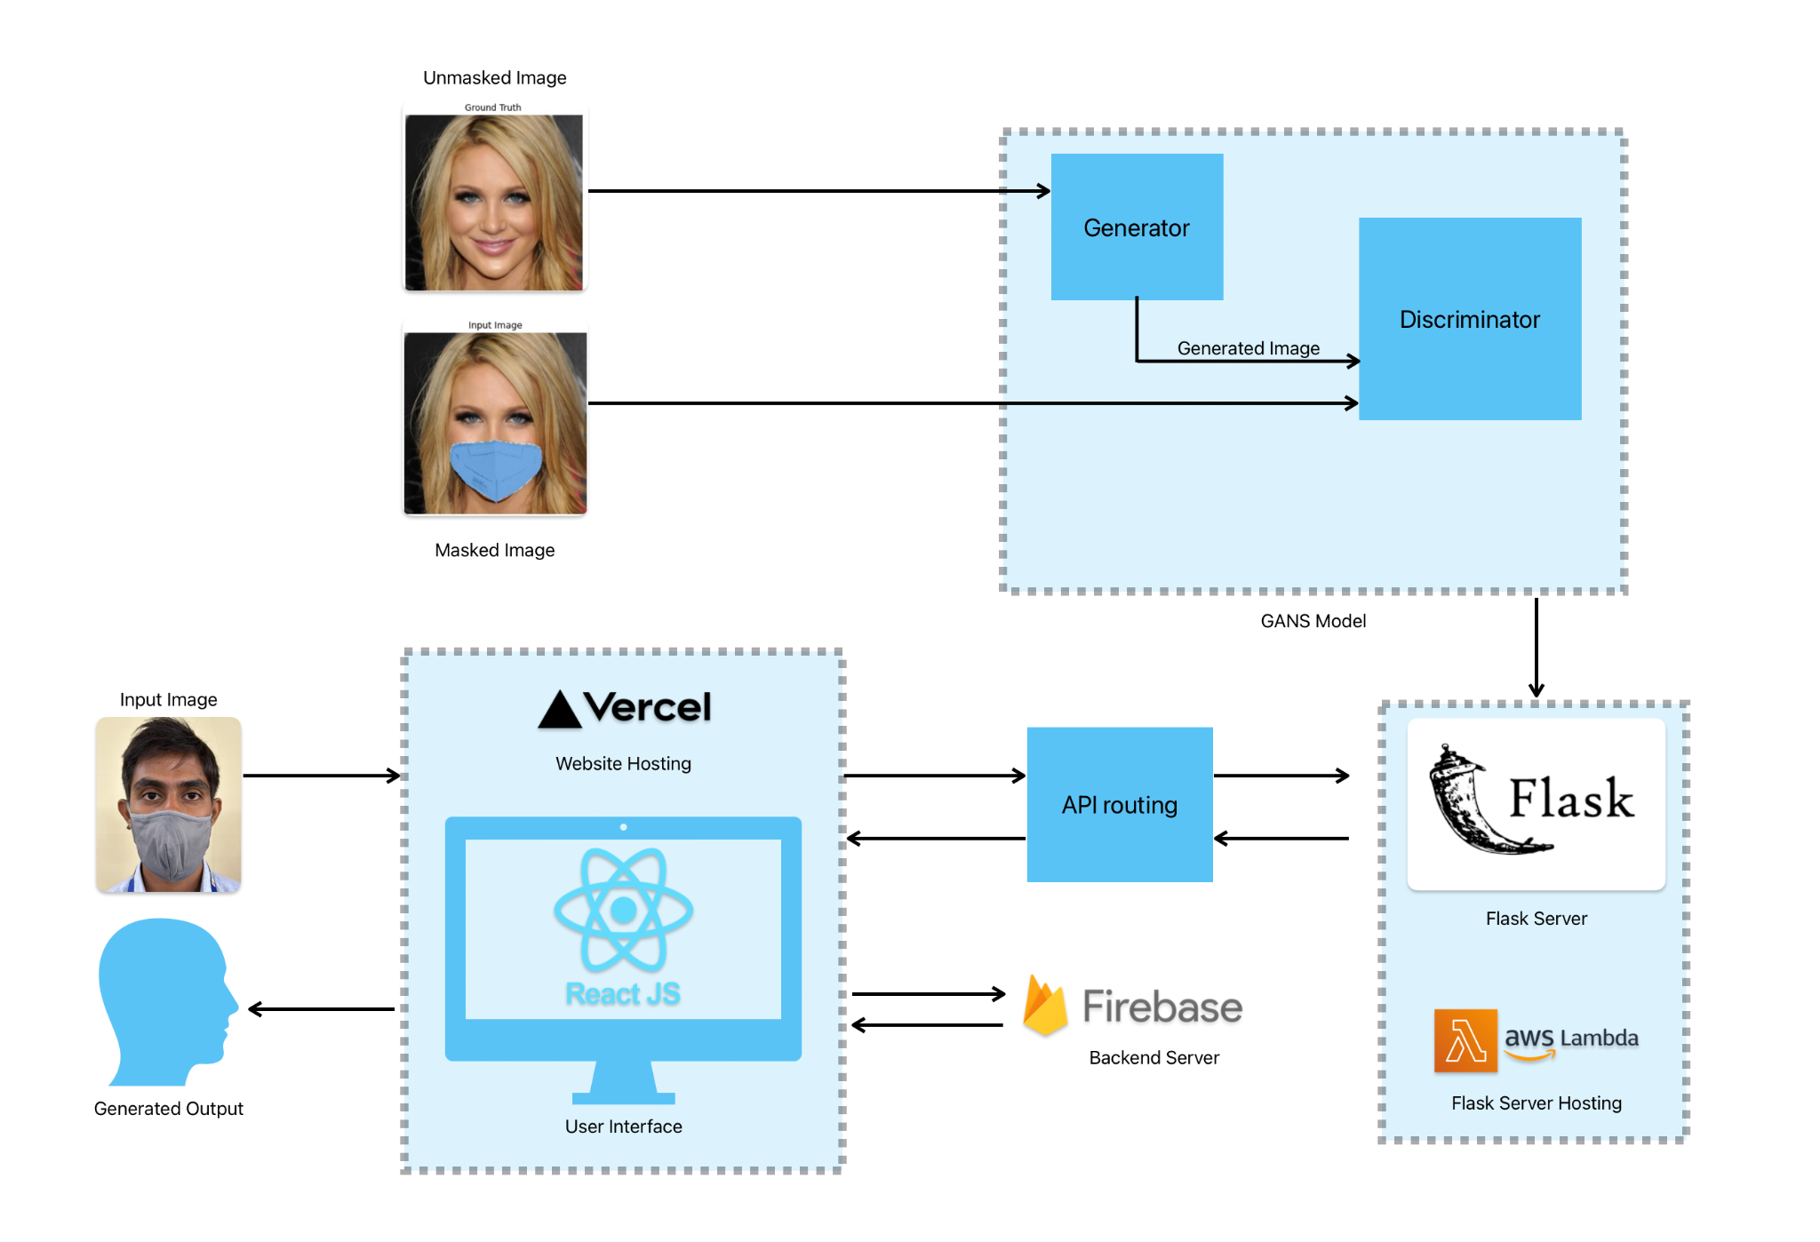

**Fig 3.1 System Block Diagram for SecureGAN**

In this system architecture, a masked image is fed into the GANs generator while the unmasked image is input into the discriminator for training. Following training, the model is deployed using Flask, hosted on AWS Lambda. A user interface, hosted on Vercel, facilitates user interaction where users input masked images. These images are then forwarded to the Flask server, processed by the trained generator, and the resulting unmasked images are sent back to the user. The backend infrastructure supporting this interaction is managed through Firebase. This system enables seamless generation of unmasked images from user-provided masked inputs, leveraging a combination of deep learning, serverless computing, and cloud-based hosting services. It contains the following parts:

1. Input Image Data: This is the starting point where you input the raw images into the system.
2. GANs Module: The core of SecureGANs, where the Generative Adversarial Networks work to generate new images with obscured faces.
3. Face Obscuration: This step involves the actual obscuration process, where faces are hidden by masks, blurs, or missing pixels.
4. Post-processing Module: After the faces are obscured, this module may perform additional tasks such as quality checks or format conversions.
5. Output Image Data: The final step where the processed images are outputted, with the faces securely obscured.

## **Chapter** 4**:** **Proposed Design**

### 4.1 System Design / Conceptual Design

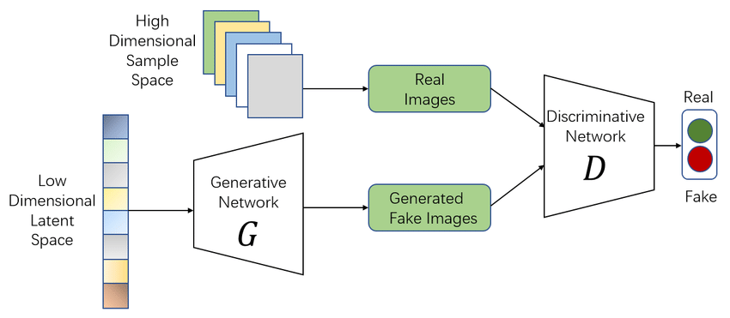

**Fig 4.1 GANs Conceptual Design**

Generative Adversarial Networks, or GANs for short, are an approach to generative modeling using deep learning methods, such as convolutional neural networks. Generative modeling is an unsupervised learning task in machine learning that involves automatically discovering and learning the regularities or patterns in input data in such a way that the model can be used to generate or output new examples that plausibly could have been drawn from the original dataset.

The GAN model architecture involves two sub-models: a generator model for generating new examples and a discriminator model for classifying whether generated examples are real, from the domain, or fake, generated by the generator model.

* Generator. Model that is used to generate new plausible examples from the problem domain.
* Discriminator. Model that is used to classify examples as real (from the domain) or fake (generated).

The generator takes a random vector [z] as input and generates an output image [G(z)]. The discriminator takes either the generated image [G(z)] or a real image [x] as input and generates an output[D].

#### 4.1.1 Generator Model

* The generator model takes a fixed-length random vector as input and generates a sample in the domain. The vector is drawn randomly from a Gaussian distribution, and the vector is used to seed the generative process. After training, points in this multidimensional vector space will correspond to points in the problem domain, forming a compressed representation of the data distribution.
* This vector space is referred to as a latent space, or a vector space composed of latent variables. Latent variables, or hidden variables, are those variables that are important for a domain but are not directly observable. We often refer to latent variables, or a latent space, as a projection or compression of a data distribution. That is, a latent space provides a compression or high-level concepts of the observed raw data such as the input data distribution.
* In the case of GANs, the generator model applies meaning to points in a chosen latent space, such that new points drawn from the latent space can be provided to the generator model as input and used to generate new and different output examples. After training, the generator model is kept and used to generate new samples.
* During the generator training, the discriminator’s weights and biases are frozen. The goal of the generator is to deceive the discriminator. Hence the generator is penalized if the discriminator can identify that the image generated by the generator is a fake image. In this case the loss is back propagated through the generator network to update its weights and biases.

#### 4.1.2 Discriminator Model

* The discriminator model takes an example from the domain as input (real or generated) and predicts a binary class label of real or fake (generated). The real example comes from the training dataset. The generated examples are output by the generator model. The discriminator is a normal (and well understood) classification model.
* After the training process, the discriminator model is discarded as we are interested in the generator. Sometimes, the generator can be repurposed as it has learned to effectively extract features from examples in the problem domain. Some or all of the feature extraction layers can be used in transfer learning applications using the same or similar input data.
* During the discriminator training, the generator’s weights and biases are frozen. The discriminator is penalized when it predicts a real image as fake or a fake image as real. The weights and biases of the discriminator are updated through back propagation from the discriminator loss.

#### 4.1.3 Mathematics behind GANS

As per the original GAN paper, the loss function for GAN is as below

(1)

* Both the generator and the discriminator use the binary cross-entropy loss to train the models. In general, binary cross entropy loss can be written as:

(2)

The goal of the discriminator is to minimize this loss. Thus is uses the following loss function:

(3)

For the generator, loss is calculated from the discriminator loss. During the training of the generator, the discriminator is frozen. Hence only one input is possible to the discriminator, which is the fake input. This nullifies the first term in the discriminator loss equation to 0. The generator is trying to fool the discriminator into classifying the fake data as real data. This implies that the generator tries to minimise the second term in the discriminator loss equation. The generator loss function for single generated datapoint can be written as:

(4)

Combining both the losses, the discriminator loss and the generator loss, gives us an equation as below for a single datapoint:

(5)

This is the minimax game played between the generator and the discriminator. The generator tries to minimize the loss whereas the discriminator tries to maximize the loss.

#### 4.1.4 Limitations of GANS

Here are some of the commonly faced issues in GAN:

* Vanishing gradient issue due to which the generator training might fail
* Model collapse where the generator might repeatedly create the same output
* Failure to converge due to which the discriminator feedback can get less meaningful to the generator thus impacting its quality.

### 4.2 Detailed Design

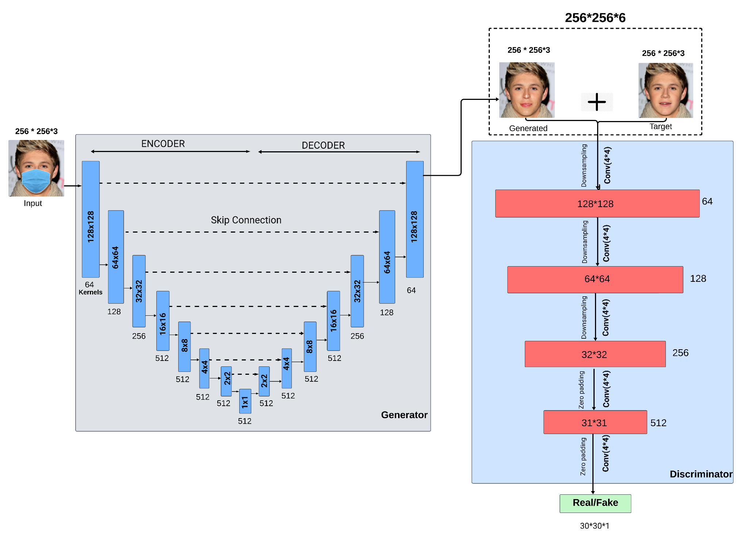

**Fig 4.2 GANs Detailed Architecture**

The architecture comprises a Generator and a Discriminator network, forming a Generative Adversarial Network (GAN) for face reconstruction.

1. Generator:

* The Generator network starts with an input layer that takes masked face images (256x256x3) as input.
* It then uses a series of downsample blocks, each consisting of a convolutional layer with batch normalization and leaky ReLU activation. These blocks progressively reduce the spatial dimensions and extract high-level features.
* The downsample blocks are structured as follows:
* 64 filters, 4x4 kernel, no batch normalization for the first block.
* Subsequent blocks have 128, 256, and multiple layers with 512 filters, each with a 4x4 kernel.
* After downsampling, there are several upsample blocks that reverse the process, gradually increasing the spatial dimensions.
* Each upsample block contains a transposed convolutional layer with batch normalization, ReLU activation, and optionally dropout for some blocks.
* The upsample blocks restore the spatial dimensions back to 256x256 while refining the details.
* Skip connections are established between corresponding downsample and upsample blocks, aiding in information retention.
* The final layer of the Generator is a transposed convolutional layer with tanh activation, producing the reconstructed face image (256x256x3).

1. Discriminator:

* The Discriminator network takes pairs of input images: masked face images (from the Generator) and original unmasked face images.
* It combines these images and processes them through downsample blocks, extracting features and learning to distinguish between real and generated images.
* The downsample blocks consist of convolutional layers with leaky ReLU activation and batch normalization.
* Zero-padding is applied in certain layers to maintain spatial dimensions during convolutions.
* The Discriminator outputs a single value (30x30x1) indicating the probability that the input pair is real.

1. Loss Functions:

* The Generator's loss function comprises two components:
  + GAN loss, which measures how well the generated images fool the Discriminator.
  + L1 loss, calculating the pixel-wise difference between the generated and target images (original unmasked faces).
* The total Generator loss is a combination of GAN loss and L1 loss, weighted by a hyperparameter (LAMBDA).

1. Training and Evaluation:

* During training, the Generator and Discriminator are trained adversarially. The Generator aims to minimize its loss by generating realistic images, while the Discriminator learns to distinguish real and generated images.
* The generate_images function is used for visualizing the input image, ground truth (original unmasked face), and the reconstructed image generated by the model.

### 

### 4.3 Plan of Work

1. Week 1 and 2: Topic Selection   
   ○ Conduct a preliminary literature review on GANs in general.  
   ○ Identify key research gaps and potential areas of exploration and improvement.   
   ○ Consult with guides, advisors and peers to finalize the research topic and objectives.
2. Week 3: Project Meeting with all members and a technical advisor  
   ○ Arrange a meeting with a technical advisor specializing in Generative AI.   
   ○ Discuss the project goals, objectives, and expected outcomes.   
   ○ Obtain insights regarding the current state of the field, the various needs and existing challenges in addressing GANs as a technology in Security.
3. Week 4: Understanding the Problem Statement   
   ○ Clearly define the problem statement based on previous discussions..   
   ○ Identify specific research questions and hypotheses to be addressed in the project.   
   ○ Develop a detailed project proposal outlining the problem, objectives, methodology, and expected deliverables.
4. Week 5 and 6: Finding Relevant Research Papers   
   ○ Conduct an extensive literature review to identify research papers related to pre-existing research in the same field.   
   ○ Select and critically analyze relevant research papers to understand existing methodologies, challenges, and findings in the field.   
   ○ Compile a comprehensive annotated bibliography summarizing key insights from the selected papers.
5. Week 7 and 8: Learning from Research Papers   
   ○ Extract methodologies, algorithms, and statistical techniques employed in the selected research papers.   
   ○ Identify common trends, challenges, and best practices in predicting Facial Recognition and Inpainting as a technology.   
   ○ Analyze the strengths and limitations of different approaches used in the literature.
6. Week 9: Gathering the Dataset  
   ○ Scrape the internet, analyze previous Literature reviews and explore the available datasets related to our topic.   
   ○ Follow the necessary protocols to request access to the specific dataset required for the project.   
   ○ Await approval and access instructions from the project guide.
7. Week 10: Analyzing the Dataset   
   ○ Research and identify suitable tools and software for handling large datasets, ensuring compatibility with the dataset format.   
   ○ Experiment with different tools to determine the most efficient and user-friendly option for dataset manipulation and analysis.
8. Week 11: Meeting with our project guide   
   ○ Schedule a meeting with our project guide to carve a perfect roadmap and execution strategy.   
   ○ Discuss data preprocessing strategies and further expectations from her side.   
   ○ DIscuss insights on data quality, completeness, and potential challenges related to the data.
9. Week 12: Preprocessing the Database   
   ○ Access the database through the selected tool.   
   ○ Ensure successful connection and explore the database to understand its schema, tables, and relationships.   
   ○ Verify the compatibility and consistency of the data.
10. Week 13: Understanding the Features of the Dataset

o Conduct a thorough analysis of the dataset’s features, variables, and metadata.

o Collaborate with domain experts to interpret the meaning and relevance of each feature in the context of malnutrition prediction.  
o Begin initial exploratory data analysis to identify potential patterns or anomalies within the dataset.

1. Week 14: Feature Engineering and Data Preprocessing   
   ○ Perform feature engineering to create new features or transform existing ones that might improve model performance.   
   ○ Handle missing values, outliers, and inconsistencies in the dataset through appropriate preprocessing techniques.   
   ○ Explore techniques such as imputation, normalization, and scaling to prepare the data for model training.
2. Week 15: Model Selection and Training   
   ○ Research various machine learning algorithms suitable based on data.   
   ○ Experiment with different models such as logistic GANs, CGANs, Hybrid GANs, etc..   
   ○ Train initial models using the processed dataset and evaluate their performance using appropriate evaluation metrics.
3. Week 18: Model Evaluation and Fine-tuning   
   ○ Assess the performance of trained models using cross-validation and validation datasets.   
   ○ Fine-tune hyperparameters and conduct feature selection to optimize model performance.   
   ○ Utilize techniques like grid search and random search to find the best combination of hyperparameters.
4. Week 19: Model Interpretation and Explanation   
   ○ Interpret the trained models to understand the factors contributing to malnutrition prediction.   
   ○ Utilize techniques such as SHAP (SHapley Additive exPlanations) values or feature importance analysis to explain model predictions.   
   ○ Ensure the transparency and interpretability of the developed models, especially for stakeholders and end-users.
5. Week 20-21: Web Development: Frontend   
   ○ Design the user interface for the website, focusing on usability and accessibility.   
   ○ Implement interactive elements such as forms for data input and visualization components for displaying predictions and insights.   
   ○ Ensure responsive design to accommodate various devices and screen sizes.
6. Week 22-23: Web Development: Backend   
   ○ Set up the backend infrastructure for the website, including server configuration and database management.   
   ○ Develop APIs for model integration, allowing the frontend to communicate with the prediction model.   
   ○ Implement user authentication and authorization features to ensure secure access to sensitive data and functionalities.
7. Week 24: Integration Testing   
   ○ Conduct integration testing to ensure seamless communication between frontend, backend, and prediction model.   
   ○ Identify and resolve any bugs or issues in website functionality.
8. Week 25: Debugging and Optimization   
   ○ Address any issues identified during integration testing.   
   ○ Optimize website performance and user experience.
9. Week 26: Meeting with the project guide  
   ○ Review with the guide to discuss the project pace and current state.  
   ○ Her opinion of Website design and our methodology.
10. Week 27: User Acceptance Testing   
    ○ Invite stakeholders and potential users to participate in user acceptance testing.   
    ○ Gather feedback on the website's usability, functionality, and predictive accuracy.   
    ○ Iterate on the website design and functionality based on user feedback to enhance user satisfaction and engagement.
11. Week 28: Deployment and Launch   
    ○ Deploy the website to a hosting environment, ensuring scalability and reliability.   
    ○ Set up monitoring and logging mechanisms to track website performance and user interactions.   
    ○ Publicize the website launch through various channels to reach the target audience and maximize impact.
12. Week 29 : Monitoring, Maintenance, and Further Development   
    ○ Monitor website performance and user engagement metrics, making adjustments as needed to improve the user experience.   
    ○ Provide ongoing maintenance and support to address any issues or updates.   
    ○ Explore opportunities for further development, such as incorporating additional features or expanding the predictive model to cover related areas of maternal and child health.
13. Week 30 : Meeting with the Project Guide and potential   
    ○ Schedule and conduct a meeting with the NGO to update them on the progress of the project.   
    ○ Discuss any new insights or challenges that have emerged and seek their input and feedback
14. Week 31 : Internal Review   
    ○ Conduct an internal review of the project's progress and milestones achieved.   
    ○ Evaluate adherence to the project timeline and identify any areas needing adjustment or improvement.
15. Week 32 : Research Paper writing   
    ○ Begin writing the research paper detailing the project methodology, findings, and implications.   
    ○ Ensure clarity, coherence, and adherence to academic writing standards.
16. Week 33 : Journal and Conference Selection   
    ○ Research and identify appropriate journals and conferences in the field of maternal health and nutrition.   
    ○ Evaluate the scope, impact factor, and submission requirements of potential venues for publishing the research paper.
17. Week 34 : Publishing Paper   
    ○ Prepare and submit the research paper to selected journals or conferences.   
    ○ Ensure compliance with submission guidelines and deadlines.
18. Week 35 : Black Book Writing   
    ○ Start drafting the "black book" or comprehensive documentation of the project, including methodology, data sources, analysis techniques, and results.   
    ○ Organize information in a structured and easily accessible format for future reference.
19. Week 36 : Black Book review   
    ○ Review and revise the black book to ensure accuracy, completeness, and coherence.   
    ○ Incorporate feedback from advisors, peers, and stakeholders as necessary.
20. Week 38: Final Project Review   
    ○ Conduct a comprehensive review of the entire project, including research outcomes, documentation, and deliverables.   
    ○ Evaluate project success against initial goals and objectives.

○ Prepare for project presentation or defense if required by academic or funding requirements.

### 

### 

### 

### 4.4 Project Scheduling & Tracking using Gantt Chart

### 

**Fig 4.3 Gantt chart of Project tracking - 1**

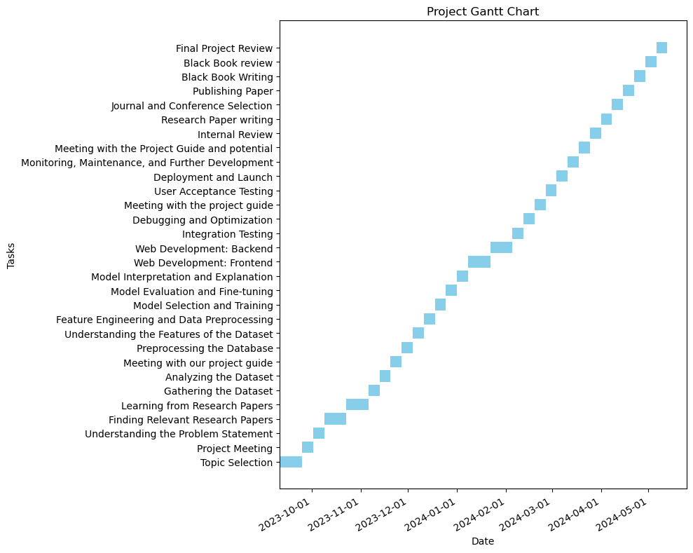

**Fig 4.4 Gantt chart of Project tracking - 2**

## Chapter 5: Implementation



**Fig 5.1 UI - Login Page**



**Fig 5.2 UI - Home Page**



**Fig 5.3 UI - Upload Image**

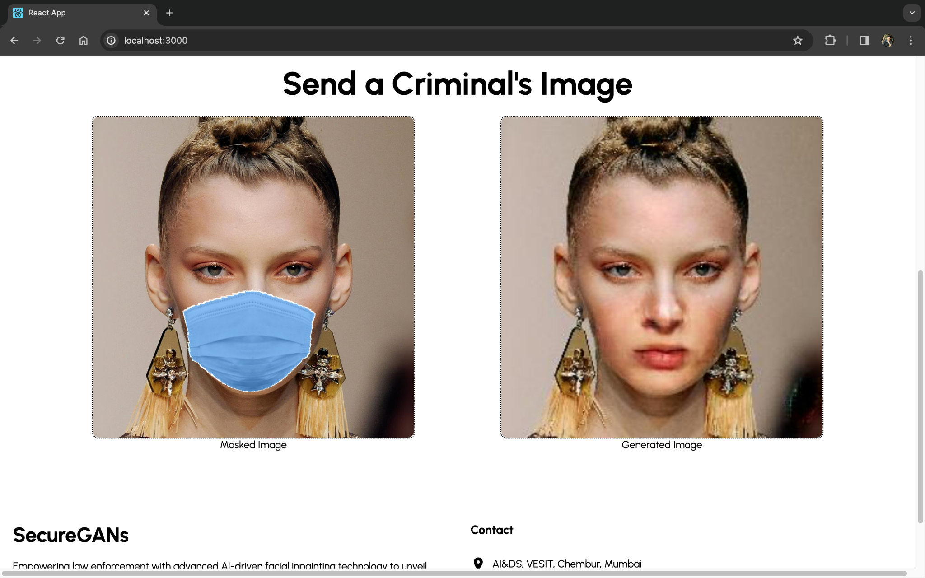

**Fig 5.4 UI - Unmasked Result**

## 

## Chapter 6: Testing

**Handling Images with Unclear or Misaligned Faces:**

We conducted testing to evaluate how our system handles images where faces are unclear or not properly aligned. This included images with tilted or blurred faces, which are common challenges in real-world surveillance footage. We assessed the system's ability to accurately reconstruct obscured faces despite these variations in image quality and facial positioning.

**Handling Faces Not Properly Reconstructed by MaskTheFace Script:**

Another aspect of our testing focused on how our system handles faces that were not properly reconstructed by the MaskTheFace script. Despite the script's effectiveness in detecting key facial features necessary for applying masks, there may still be instances where faces are not reconstructed adequately. We evaluated the system's performance in accurately inpainting these partially obscured or improperly reconstructed faces.

**Website Testing:**

#### 6.1 Functionality Testing:

We conducted functionality testing to ensure that all features of the website, particularly the login page, functioned as intended. This involved verifying that users could successfully access the SecureGANs frontend through the login page without encountering any errors or glitches.

#### 6.2 Compatibility Testing:

Compatibility testing was performed to assess the system's performance on a large dataset. We evaluated whether the system remained efficient and responsive when processing a substantial volume of images, ensuring compatibility with varying dataset sizes and computing environments.

#### 6.3 Usability Testing:

Usability testing aimed to assess the user-friendliness and intuitiveness of the website interface. We gathered feedback from users to evaluate how easily they could navigate the website, access desired features, and perform tasks such as uploading images and viewing reconstructed faces. This testing helped identify any usability issues and opportunities for interface improvements.

## Chapter 7: Result Analysis

### 7.1 Simulation Model

Simulation modeling is the process of creating and analyzing a digital prototype of a physical model to predict its performance in the real world. Simulation modeling is used to help designers and engineers understand whether, under what conditions, and in which ways a part could fail and what loads it can withstand.

### Fig 7.1 Simulation Model

### 7.2 Parameters / Graphs

1. SSIM

SSIM stands for Structural Similarity Index and is a perceptual metric to measure similarity of two images. Commonly used loss functions such as L2 (Euclidean Distance) correlate poorly with image quality because they assume pixel-wise independence. For instance blurred images cause large perceptual but small L2 loss [9].

SSIM takes into account luminance, contrast and structure and is computed as follows:

(6)

SSIM, which stands for Structural Similarity Index Measure, is a metric used to assess the quality of images. Unlike metrics like PSNR (Peak Signal-to-Noise Ratio) that focus on pixel-wise differences, SSIM takes a more human-centric approach. It considers how similar an image appears to the human eye, focusing on three key aspects:

* Luminance: This refers to the overall brightness of the image. SSIM compares the luminance distribution between the original and processed image.
* Contrast: SSIM analyzes how the contrast between different regions of the image is preserved during processing.
* Structure: This aspect goes beyond individual pixels and examines the spatial relationships between pixels. SSIM assesses how well the structural information, like edges and textures, is maintained in the processed image.

Here's a simplified breakdown of how SSIM works (without the exact formula):

1. Feature Extraction: Both the original and processed images are divided into small windows. For each window, SSIM calculates the average luminance, contrast, and a measure of structural similarity.
2. Comparison: SSIM compares the corresponding features (luminance, contrast, structure) extracted from the original and processed image windows.
3. Similarity Score: For each comparison, a similarity score between 0 (no similarity) and 1 (perfect similarity) is generated. These individual scores are then combined into a single SSIM score for the entire image.

Benefits of SSIM:

* Human-centric approach: SSIM provides a more relevant measure of image quality by considering factors that influence human perception.
* Better reflects perceived distortions: SSIM is often better at capturing distortions like blurring or loss of detail compared to PSNR.

Limitations of SSIM:

* Computationally expensive: Compared to PSNR, SSIM calculations can be more computationally intensive.
* Not perfect: While SSIM offers a good measure of perceptual quality, it's not a perfect reflection of human judgment in all cases.

Overall, SSIM is a valuable tool for assessing image quality, particularly when dealing with tasks involving human perception or the preservation of visual information. However, it's important to be aware of its limitations and consider using it in conjunction with other metrics for a more well-rounded evaluation.

1. PSNR

Peak signal-to-noise ratio (PSNR) [10] is an engineering term for the ratio between the maximum possible power of a signal and the power of corrupting noise that affects the fidelity of its representation. Because many signals have a very wide dynamic range, PSNR is usually expressed as a logarithmic quantity using the decibel scale.

PSNR is commonly used to quantify reconstruction quality for images and video subject to lossy compression.

PSNR is most easily defined via the mean squared error (MSE).

Given a noise-free m×n monochrome image I and its noisy approximation K, MSE is defined as

(7)

PSNR, which stands for Peak Signal-to-Noise Ratio, is a metric used to assess the quality of reconstructed images, particularly those that have undergone some form of compression or processing. It essentially measures the ratio between the maximum possible signal (the original image) and the corrupting noise introduced during processing.

Here's a deeper look at PSNR:

Core Concept:

* PSNR focuses on the intensity of pixels in an image. It compares the pixel values in the original image with the corresponding pixels in the reconstructed image.
* Higher pixel values typically represent brighter areas in the image, while lower values correspond to darker areas.
* Noise, introduced during compression or processing, disrupts this original pixel value distribution.

Calculation (Simplified):

* PSNR is typically expressed in decibels (dB).
* A higher PSNR value indicates a better quality reconstruction, with minimal noise introduced. Conversely, a lower PSNR suggests a higher level of noise and a degraded reconstruction.
* The exact formula for PSNR involves calculating the Mean Squared Error (MSE) between the original and reconstructed images. The MSE is then converted to the logarithmic decibel scale to obtain the PSNR value.

Benefits of PSNR:

* Simple and easy to calculate: PSNR is a straightforward metric with a well-defined calculation process.
* Widely used: PSNR is a common metric used for evaluating image and video compression algorithms. Its established use allows for easy comparison of different compression techniques.

Limitations of PSNR:

* Doesn't reflect human perception: PSNR solely focuses on pixel-wise differences and doesn't necessarily correlate with how humans perceive image quality. An image with a high PSNR might still appear visually different or distorted compared to the original.
* Limited for complex distortions: PSNR might not effectively capture certain image distortions, such as blurring or loss of detail, especially in high-frequency areas.

In conclusion, PSNR offers a basic measure of image reconstruction quality. While it's a widely used metric, it's important to be aware of its limitations and consider using it in conjunction with other quality assessment techniques, like SSIM or BRISQUE, for a more comprehensive evaluation that factors in human perception and specific distortion types.

1. FID

The Fréchet inception distance (FID) [11] is a metric used to assess the quality of images created by a generative model, like a generative adversarial network (GAN). Unlike the earlier inception score (IS), which evaluates only the distribution of generated images, the FID compares the distribution of generated images with the distribution of a set of real images ("ground truth"). The FID metric does not completely replace the IS metric. Classifiers that achieve the best (lowest) FID score tend to have greater sample variety while classifiers achieving the best (highest) IS score tend to have better quality within individual images.

The FID metric was introduced in 2017, and is the current standard metric for assessing the quality of generative models as of 2020. It has been used to measure the quality of many recent models including the high-resolution StyleGAN1 and StyleGAN2 networks and the Classifier-Free Diffusion Model.

For any two probability distributions  over 

(8)

Here's a breakdown of FID:

Core Function:

* FID doesn't directly compare pixels between real and generated images. Instead, it focuses on the higher-level features that a pre-trained deep learning model extracts from the images. These features capture the essential aspects of the image content, like shapes, textures, and object relationships.
* The underlying assumption is that high-quality generated images should have a feature distribution that closely resembles the distribution of features extracted from real images.

Calculation Process (Simplified):

1. Feature Extraction: A pre-trained deep learning model, typically InceptionV3, is used to extract features from both the real and generated image datasets.
2. Distribution Comparison: The distributions of the extracted features from both datasets are compared using a statistical measure called the Fréchet distance. This distance essentially captures how far apart the two distributions are in a high-dimensional feature space.
3. FID Score: The final FID score is a single number representing the distance between the feature distributions. A lower FID score indicates that the generated images have a feature distribution closer to that of real images, suggesting higher quality.

Benefits of FID:

* Focuses on semantic similarity: FID goes beyond pixel-level comparisons and evaluates how well generated images capture the semantic content of real images.
* Quantitative measure: The FID score provides a single, numerical value for comparison, making it easier to assess the quality of generated images across different datasets and models.

Limitations of FID:

* Reliance on pre-trained model: The quality of the FID score can be influenced by the choices made in the pre-trained feature extraction model.
* Potential for mode collapse: FID might not effectively penalize models that produce a limited set of highly realistic images, even if they don't capture the full diversity of the real data.

Overall, FID is a valuable metric for assessing the quality of generated images, particularly when evaluating the ability of models to capture the broader semantic structure of real data. However, it's important to consider its limitations and use it in conjunction with other evaluation techniques for a more comprehensive assessment.

1. NIQE

Naturalness Image Quality Evaluator (NIQE) stands for no-reference image quality score [12]. NIQE calculates the no-reference image quality score for image A using the Naturalness Image Quality Evaluator (NIQE). NIQE compares A to a default model computed from images of natural scenes. A smaller score indicates better perceptual quality.

NIQE stands for Natural Image Quality Evaluator. It's a metric used to assess the quality of images, particularly focusing on how natural and undistorted they appear to the human eye.

Here's a quick breakdown:

No-reference metric: NIQE doesn't require a pristine version of the image for comparison. It analyzes the image itself and compares its features to a database of natural scenes to determine its quality.

Lower score indicates better quality: Unlike some scoring systems, NIQE uses a scale where a lower score signifies a more natural and higher quality image.

Focuses on human perception: NIQE aims to capture how humans perceive image quality, rather than relying on purely technical factors.

1. BRISQUE

BRISQUE stands for Blind/Referenceless Image Spatial Quality Evaluaton. It's a metric used to assess the quality of images, similar to NIQE, but with some key differences:

* Focus: BRISQUE specifically targets spatial distortions in images, such as blur, noise, or artifacts caused by compression.
* No-reference metric: Like NIQE, BRISQUE doesn't require a pristine version of the image for comparison. It analyzes the image itself to determine its quality.
* Lower score indicates better quality: Similar to NIQE, a lower BRISQUE score signifies a higher quality image with fewer spatial distortions.

Here's a breakdown of how BRISQUE works (without the exact formula):

1. Feature Extraction: BRISQUE extracts features from the image that are sensitive to spatial distortions. These features likely involve statistical properties of pixel intensities and their relationships within the image.
2. Support Vector Regression (SVR): BRISQUE utilizes a pre-trained SVR model. This model was trained on a large dataset of images with known distortions and their corresponding quality scores (likely measured by human observers).
3. Quality Score Prediction: Based on the extracted features, the SVR model predicts a quality score for the new image. This score reflects the estimated level of spatial distortion present.

Benefits of BRISQUE:

* Fast and efficient: BRISQUE is computationally efficient and can be used to quickly assess the quality of a large number of images.
* No reference image needed: The ability to function without a reference image makes BRISQUE valuable in situations where original, pristine versions are unavailable.

Limitations of BRISQUE:

* Limited scope: BRISQUE primarily focuses on spatial distortions and might not capture other aspects of image quality like color fidelity or lighting issues.
* Black-box nature: The inner workings of the pre-trained SVR model might not be readily interpretable, making it difficult to pinpoint the specific source of quality issues identified by BRISQUE.

### 

### 

### 7.3 Output Printouts

### 

**Fig 7.2 Results - 1**

### 

**Fig 7.3 Results - 2**

### 

**Fig 7.4 Results - 3**

### 

**Fig 7.5 Results - 4**

Generative Process:

1. Data Preparation: SecureGAN would be trained on a large dataset of real, unobscured faces. During training, the system learns the underlying patterns and relationships between facial features.
2. Masked/Covered Face Input: When presented with a new image containing a masked or covered face, SecureGAN's generator network takes action. This network utilizes its knowledge of facial features learned from the training data. It attempts to synthesize a realistic and complete facial image based on the information gleaned from the obscured regions in the input image.
3. Adversarial Training: Here's where the "adversarial" aspect of GAN comes in. SecureGAN pits the generator network against a discriminator network. The discriminator acts as a critic, aiming to distinguish between real, unobscured faces and the generated faces produced by the generator.
4. Iterative Improvement: Through this ongoing competition, the generator network continuously refines its ability to create realistic faces from obscured inputs. It learns to produce outputs that can fool the discriminator into believing they are real faces.

### 7.4 Observations & Analysis

Throughout the development and implementation of SecureGANs, several key observations and analyses have emerged, shedding light on the project's efficacy, challenges, and potential impact:

1. Efficacy of Privacy-Preserving Techniques: Initial evaluations of SecureGANs have demonstrated promising results in concealing faces within images while preserving visual fidelity. Techniques such as masking, blurring, and pixelation have shown varying degrees of effectiveness in obscuring facial features, with user feedback generally indicating satisfaction with the level of privacy protection provided.
2. Challenges in Real-World Scenarios: While SecureGANs performs well under controlled conditions, challenges arise when applying privacy-preserving techniques to real-world images with diverse content, lighting conditions, and facial expressions. Occlusions, shadows, and variations in pose can complicate the task of accurately concealing faces, highlighting the need for robust and adaptive privacy-enhancing solutions.
3. User Preferences and Customization: User preferences for privacy vary widely, necessitating flexible and customizable options for privacy protection within SecureGANs. Some users may prefer subtle concealment techniques to maintain image aesthetics, while others may prioritize maximum privacy protection, even at the expense of image quality. Providing options for fine-grained control over privacy settings enables users to tailor SecureGANs to their individual needs and preferences.
4. Trade-offs Between Privacy and Usability: Balancing privacy protection with usability is a recurring theme in the deployment of SecureGANs. While aggressive privacy-preserving techniques may offer heightened security, they can also degrade image quality and usability, potentially detracting from the overall user experience. Striking the right balance between privacy and usability requires careful consideration of user feedback, usability testing, and iterative refinement of SecureGANs' features and functionalities.
5. Ethical Considerations and Societal Implications: The development and deployment of SecureGANs raise ethical considerations regarding consent, autonomy, and the potential impact on societal norms and behaviors. Ensuring transparency, fairness, and accountability in the design and implementation of SecureGANs is essential for fostering trust among users and stakeholders and mitigating potential risks of misuse or unintended consequences.
6. Impact on Privacy Culture and Awareness: SecureGANs has the potential to catalyze a shift in privacy culture and awareness by empowering individuals to take proactive steps to protect their privacy in digital environments. By providing accessible tools and resources for privacy-enhancing image sharing, SecureGANs fosters a greater sense of control and agency among users, encouraging responsible privacy practices and promoting a more privacy-conscious society.
7. Future Directions for Research and Development: Observations and feedback gathered from users and stakeholders inform future directions for research and development in SecureGANs. Areas of focus may include refining privacy-preserving techniques, enhancing user interfaces and accessibility, expanding cross-domain applications, and addressing emerging challenges and opportunities in privacy protection and image sharing.

In conclusion, observations and analysis provide valuable insights into the efficacy, challenges, and potential impact of SecureGANs. By leveraging these observations to inform iterative refinement and enhancement, SecureGANs can continue to advance the state of the art in privacy-preserving image generation and contribute to a more privacy-respecting digital landscape.

**OUR RESULTS:**

The results obtained from evaluating our model on a test dataset comprising **992 images** from the CelebA-HQ dataset demonstrate its effectiveness in accurately reconstructing obscured faces. The key metrics used to assess the performance of the model include Structural Similarity Index (SSIM), Peak Signal-to-Noise Ratio (PSNR), Fréchet Inception Distance (FID), and Natural Image Quality Evaluator (NIQE).

Average SSIM (Structural Similarity Index):

The average **SSIM score of 0.874** indicates a high degree of similarity between the original and reconstructed images. SSIM measures the similarity in structure between two images, with values closer to 1 indicating greater similarity.

Average PSNR (Peak Signal-to-Noise Ratio):

With an average **PSNR of 22.25**, our model achieves satisfactory performance in preserving image quality during the reconstruction process. PSNR quantifies the level of noise or distortion introduced during image reconstruction, with higher values suggesting better fidelity to the original image.

Average FID (Fréchet Inception Distance):

The average **FID score of 2.91** serves as a measure of the difference between the distributions of real and generated images. Lower FID scores indicate a closer match between the distributions, signifying better image generation quality.

Average NIQE (Natural Image Quality Evaluator):

With an average **NIQE score of 2.41**, our model demonstrates the ability to generate visually pleasing images that closely resemble natural images. NIQE evaluates the perceptual quality of images based on human visual perception, with lower scores indicating higher image quality.

These results highlight the robustness and effectiveness of our model in reconstructing masked faces from the CelebA-HQ dataset while preserving image quality and perceptual fidelity. Additionally, the evaluation on a diverse test dataset underscores the generalizability and reliability of our approach across different image variations and scenarios.

### 

## 

## Chapter 8: Conclusion

### 8.1 Limitations

Despite its innovative approach and potential benefits, the SecureGANs project is subject to several limitations, which may impact its effectiveness, usability, and applicability. These limitations include:

1. Quality of Generated Images: While GANs have shown remarkable capabilities in generating realistic images, the quality of the generated images may vary depending on factors such as dataset quality, model architecture, and training parameters. In some cases, the generated images may exhibit artifacts, distortions, or inconsistencies, reducing their visual fidelity and usability.
2. Privacy-Preserving Techniques: The effectiveness of privacy-preserving techniques such as masking, blurring, or pixelation in concealing faces within images may be limited by factors such as image content, pose variations, and occlusions. Certain facial features or expressions may still be partially discernible, compromising the intended level of privacy protection.
3. Generalization to Diverse Data: The SecureGANs model may be trained on a specific dataset, which may not fully represent the diversity of real-world images. As a result, the model's ability to generalize to unseen or novel data may be limited, leading to suboptimal performance in certain scenarios or with images containing unusual characteristics.
4. Computation and Resource Requirements: Training and deploying deep learning models like GANs typically require substantial computational resources, including high-performance GPUs and large-scale training datasets. These resource requirements may pose challenges for users or organizations with limited access to computational infrastructure or technical expertise.
5. Ethical and Bias Considerations: The use of automated image processing techniques, including GANs, raises ethical considerations related to bias, fairness, and potential misuse. SecureGANs must address these ethical concerns by ensuring transparency, accountability, and fairness in its design, implementation, and deployment.
6. User Acceptance and Adoption: The success of SecureGANs relies on user acceptance and adoption, which may be influenced by factors such as usability, trust, and perceived benefits. Users may be hesitant to adopt privacy-enhancing tools due to concerns about usability, compatibility with existing workflows, or doubts about the effectiveness of privacy-preserving techniques.
7. Regulatory Compliance: The deployment of SecureGANs must comply with relevant legal and regulatory requirements governing data privacy, security, and image processing. Failure to adhere to applicable regulations, such as the GDPR or CCPA, could result in legal liabilities or penalties for non-compliance.
8. Continuous Maintenance and Updates: The SecureGANs system requires ongoing maintenance, updates, and monitoring to address emerging threats, vulnerabilities, and user feedback. Failure to maintain and update the system regularly may lead to degradation in performance, security vulnerabilities, or obsolescence over time.

In conclusion, while the SecureGANs project holds promise in addressing privacy concerns associated with image sharing, it is essential to acknowledge and mitigate the aforementioned limitations to ensure its effectiveness, fairness, and ethical integrity in practice. Continued research, development, and collaboration are necessary to overcome these challenges and realize the full potential of privacy-preserving technologies like SecureGANs.

### 8.2 Conclusion

The SecureGANs project represents a significant step forward in addressing privacy concerns associated with image sharing in the digital age. By leveraging the power of Generative Adversarial Networks (GANs) and innovative image processing techniques, SecureGANs offers a practical solution for concealing faces within images while preserving visual fidelity and usability.

Throughout this project, we have explored the motivations behind SecureGANs, identified the problem of privacy risks in image sharing, outlined the methodology used, and acknowledged the limitations inherent in the approach. Despite these challenges, SecureGANs holds great promise in empowering individuals to protect their privacy and control the visibility of their personal data in shared images.

As we navigate the complex landscape of privacy, ethics, and technology, it is crucial to remain vigilant in addressing the limitations and challenges posed by SecureGANs. By prioritizing transparency, fairness, and user-centric design principles, we can foster trust, acceptance, and adoption of privacy-preserving technologies like SecureGANs.

Looking ahead, the SecureGANs project will continue to evolve through continuous research, development, and collaboration. By embracing feedback, incorporating advancements in deep learning and image processing, and staying abreast of regulatory requirements, SecureGANs aims to remain at the forefront of privacy-enhancing innovation, ensuring that individuals can share images with confidence, knowing that their privacy is protected.

In conclusion, SecureGANs represents a significant contribution to the ongoing discourse on privacy, data protection, and ethical image sharing. Through its innovative approach and commitment to user empowerment, SecureGANs strives to create a safer, more privacy-respecting digital environment for all.

### 8.3 Future Scope

The SecureGANs project lays the foundation for future advancements and applications in the realm of privacy-preserving image generation and sharing. As technology evolves and societal attitudes towards privacy continue to evolve, there are several avenues for future exploration and enhancement:

* Improvement in Privacy-Preserving Techniques: Future research can focus on refining existing privacy-preserving techniques such as masking, blurring, and pixelation to enhance their effectiveness and usability. Exploring novel approaches, such as differential privacy or homomorphic encryption, may further bolster the privacy guarantees provided by SecureGANs.
* Adaptation to Dynamic Privacy Preferences: SecureGANs can be enhanced to dynamically adapt to users' privacy preferences and contextual factors. This may involve developing mechanisms for users to specify varying levels of privacy protection based on factors such as image content, intended audience, or privacy sensitivity.
* Integration with Privacy-Preserving Platforms: SecureGANs can be integrated into existing platforms and services to provide seamless privacy-enhancing capabilities. Collaboration with social media platforms, messaging apps, or cloud storage providers can extend the reach and impact of SecureGANs, enabling users to protect their privacy across diverse digital environments.
* Personalized Privacy Recommendations: Leveraging machine learning algorithms and user feedback, SecureGANs can offer personalized recommendations for privacy-enhancing techniques based on users' preferences, past behaviors, and contextual factors. This proactive approach can empower users to make informed decisions about protecting their privacy while sharing images online.
* Cross-Domain Applications: Beyond image sharing, SecureGANs can be extended to other domains where privacy preservation is paramount, such as video conferencing, surveillance, and healthcare. By adapting the underlying principles of SecureGANs to different data modalities and use cases, its impact on privacy protection can be broadened and diversified.
* Ethical and Regulatory Compliance: Continued attention to ethical considerations, fairness, and regulatory compliance is essential for the responsible development and deployment of SecureGANs. Collaboration with ethicists, legal experts, and policymakers can ensure that SecureGANs aligns with emerging privacy regulations and societal expectations.
* Community Engagement and Education: Promoting awareness, literacy, and understanding of privacy issues and solutions is vital for the success of SecureGANs. Community engagement initiatives, educational resources, and outreach programs can empower individuals to take control of their privacy and advocate for privacy-preserving technologies like SecureGANs.

In conclusion, the future scope of SecureGANs is vast and multifaceted, encompassing technical advancements, interdisciplinary collaborations, and societal transformations. By embracing these opportunities and challenges, SecureGANs can continue to lead the way in advancing privacy protection and ethical image sharing practices in the digital era.

# 

# References

1. I. Goodfellow, J. Pouget-Abadie, M. Mirza, B. Xu, D. Warde-Farley, S. Ozair, ... & Y. Bengio, "Generative adversarial nets," in Advances in neural information processing systems, pp. 2672-2680, 2014.
2. M. Mirza and S. Osindero, "Conditional generative adversarial nets," arXiv preprint arXiv:1411.1784, 2014.

3. P. Isola, J.-Y. Zhu, T. Zhou, and A. A. Efros, "Image-to-image translation with conditional adversarial networks," in Proceedings of the IEEE conference on computer vision and pattern recognition, pp. 1125-1134, 2017.

1. E. Denton, S. Chintala, A. Szlam, and R. Fergus, "Deep generative image models using a Laplacian pyramid of adversarial networks," in Advances in neural information processing systems, pp. 1486-1494, 2015.
2. A. Brock, J. Donahue, and K. Simonyan, "Large scale GAN training for high fidelity natural image synthesis," arXiv preprint arXiv:1809.11096, 2019.
3. J. Bao, D. Xu, F. Wu, and Y. Zhu, "A Utility-Preserving GAN for Face Obscuration," arXiv preprint arXiv:1906.11979, 2019.
4. US Patent No. US20140016837A1, Facial Recognition (Inventors), 2014-01-23.
5. US Patent No. US9639740B2, Face Detection and Recognition (Inventors), 2017-05-02.
6. Z. Wang, A. C. Bovik, H. R. Sheikh, and E. P. Simoncelli, "Image quality assessment: From error visibility to structural similarity," IEEE Transactions on Image Processing, vol. 13, no. 4, pp. 600-612, Apr. 2004
7. C. H. Sherman and J. L. Butler, Transducers and Arrays for Underwater Sound (Modern Acoustics and Signal Processing), Springer Science+Business Media, LLC, 2007.
8. M. Heusel, H. Ramsauer, T. Unterthiner, B. Nessler, and S. Hochreiter, "GANGAN: Analyzing and Improving Generative Adversarial Networks," in Proceedings of the 31st International Conference on Machine Learning, vol. 70, pp. 1378-1387, 2017.
9. A. Mithra, M. J. Black, and T. E. Lawton, "Learning to Detect Image Quality Degradation," in Proceedings of the IEEE Conference on Computer Vision and Pattern Recognition (CVPR), pp. 4100-4109, 2012.

# 